- Wednesday, January 9  - @ 1:00 PM  Oasis INformation Session  Expanding Oasis for XXX!  Oasis is a senior-driven program that helps support seniors living in the community. Queen’s University would like to invite you join us Wednesday, January 9th at 1 PM in the XXX Rec Centre to learn more about the Oasis program and how XXX Estates can be involved!  Light refreshments will be provided!  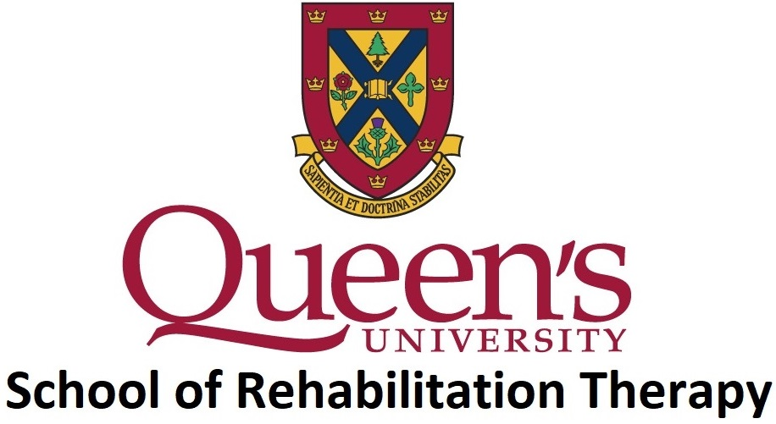  A project led by:  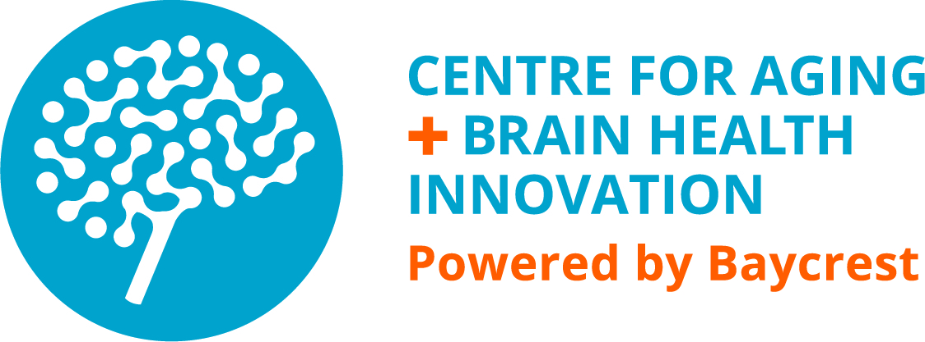  And supported by: |  | OASIS PROGRAMMING FOCUSES ON NUTRITION, SOCIALIZATION AND PHYSICAL ACTIVITY AND SERVES TO COMPLEMENT YOUR EXISTING ACTIVITIES!  OASIS CONNECTS YOU TO COMMUNITY SERVICES AND PROGRAMS AND BRINGS THEM TO YOU!  AN ONSITE COORDINATOR HELPS SUPPORT THE PROGRAMMING YOU CHOOSE!  OAsis creates a supportive network of members with a family-like feel!  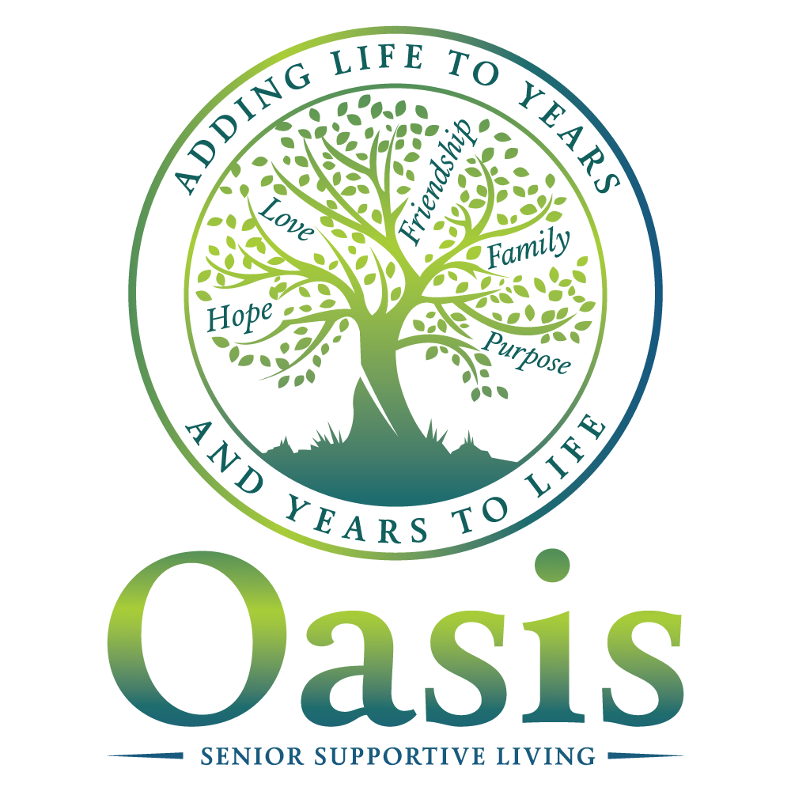

What is Oasis?

Oasis creates a way for older adults to keep their independence by building a supportive community that changes as they change.

History of Oasis

Oasis began ten years ago by a group of older adults living in an apartment building in Kingston, Ontario. The idea was to bring programming and services to the building to benefit residents' well-being.
Oasis Programming

An onsite Coordinator will support daily programming related to socialization, nutrition and activity, and will connect you to community service providers.

Examples of this programming include communal meals, exercise classes, card nights, coffee hour and more. However, as a member of Oasis you decide what programming best suits the needs of your group.

There are no membership fees; however, there may be small costs associated with certain programming.

For more information and to RSVP:  Simone Parniak  Community Developer  School of Rehabilitation Therapy  Queen’s University  343-364-6015  Simone.parniak@queensu.ca | Project Leads:  Dr. Catherine Donnelly  Dr. Vince DePaul  Oasis.study@queensu.ca

